Step by Step guide to generate BIRT report

1. Type the URL and press the Attack button.

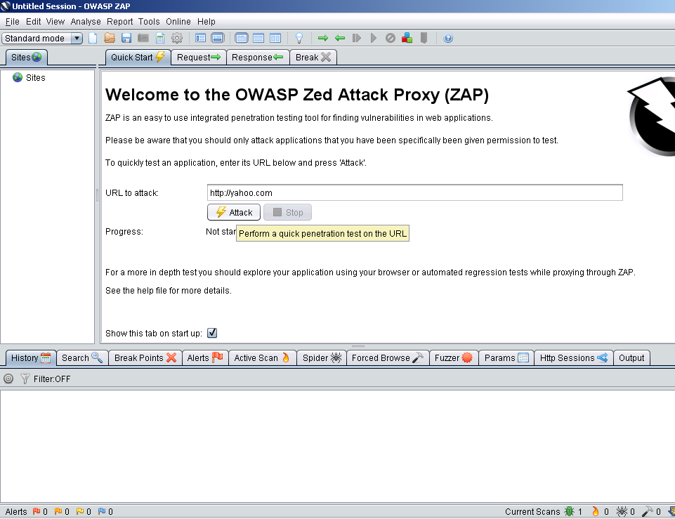

2. The results will be shown under the “Alerts” tab as shown in the following figure:

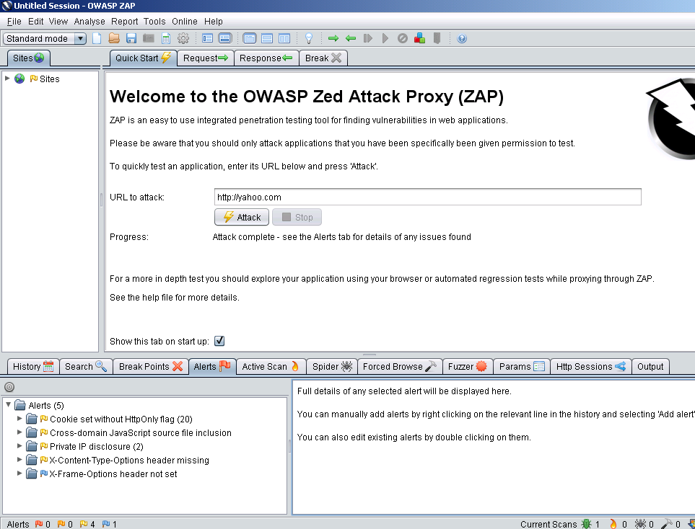

3. Click on Report→ Upload BIRT Report logo to upload the logo for the BIRT Report.

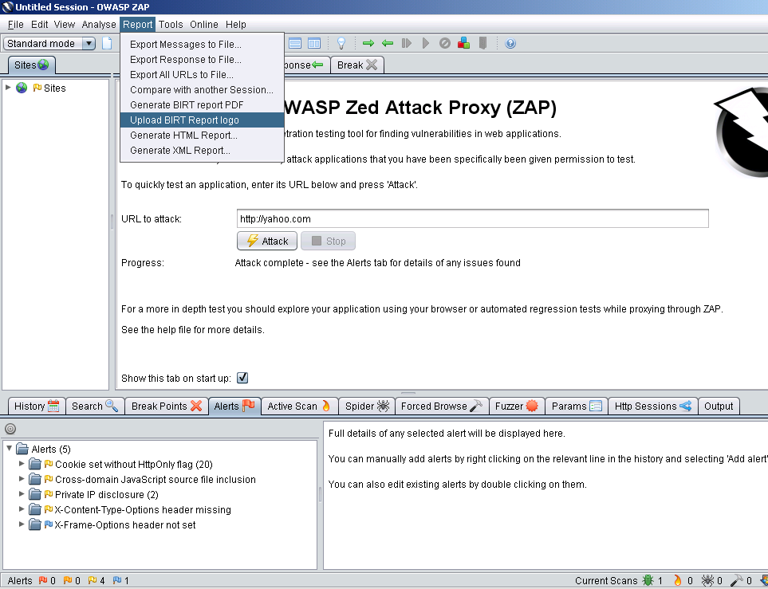

4. After uploading the logo, generate the report by clicking Report → Generate BIRT report PDF

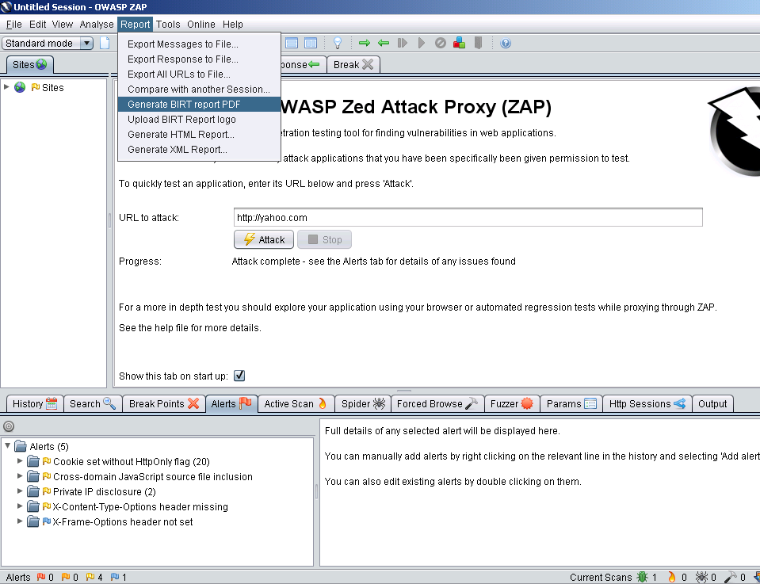

5. Enter the name and location of the PDF file to save on the disk. The file shall be saved on the specified location and open up in Acrobat reader application as shown in the following figure.

